Grade 1 — “Trading Cards of Change”
Objective & Standards
· State two accurate facts about a chosen figure and explain why it matters; produce a hero trading card.
· Standards: RL.1.1, RI.1.3, W.1.2, SL.1.4
Materials & Academic Vocabulary
· Book; fact slips (1–2 lines per figure); trading-card template (front/back).
· Vocabulary: segregation, boycott, inventor, botanist, entrepreneur, poet, equality
Lesson Flow (40–45 min)
1. Hook (5): “Then vs. Now” picture sort (segregated bus vs. today; typewriter vs. laptop).
2. Close Read (10): Revisit 2–3 pages; pull two facts.
3. Model (7): Build a sample card for Maya Angelou (2 facts + why it matters).
4. Create (15): “___ was a ___ who ____. This matters because ____.” Draw portrait (front).
5. Gallery Walk (3): One “glow” sticky note.
Differentiation • Assessment
· Differentiation: fact slips to glue; word bank; optional voice-to-text; challenge—add a second “why.”
· Assessment: rubric check (2 facts, 1 why, legible, on-task); exit—read card to a partner.

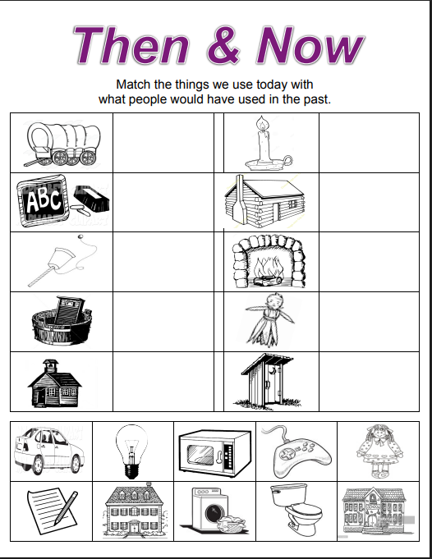

To download this, follow this link: https://www.teacherspayteachers.com/Product/Then-and-Now-Sort-2122174
Hit “View Preview” then Download.

Template — Grade 1 Trading Card (Front)
  [Portrait area — glue/draw]
  Name: ______________________________
  Role (e.g., poet, inventor, leader): _____________
  Era/Year(s): ________________________
  Set #: ________
  [Portrait area — glue/draw]
  Name: ______________________________
  Role (e.g., poet, inventor, leader): _____________
  Era/Year(s): ________________________
  Set #: ________

Template — Grade 1 Trading Card (Back)
  Fact 1: _________________________________________
  Fact 2: _________________________________________
  Why it matters: __________________________________
  Sentence: “___ was a ___ who ____. This matters because ____.”
  Signature: _______________________
  Fact 1: _________________________________________
  Fact 2: _________________________________________
  Why it matters: __________________________________
  Sentence: “___ was a ___ who ____. This matters because ____.”
  Signature: _______________________

Writing

· __________ was a __________ who ____________________.
· This matters because ____________________.
· My community can help by ____________________.
· Today I helped by ____________________.
NAME:
___________________________________________________________________

